English activity

Invent a new product which can be used around the house. This could be anything that you think would be useful.

* A broom which hoovers at the press of a button
* A multi-use toy which can transform into a football, a baseball bat, a golf club etc.
* A cake maker where all the ingredients are put in whole and it makes the cake for you

Use your imagination and be creative!

Got your product? Create an advertising billboard/poster for it.

How will you make it eye-catching? Make sure people know what your product is and what it does. Include a price and think about persuasive language e.g. the best new invention on the market. You may want to use a rhetorical question such as: Are you fed up with slaving away cleaning all day?

Maths activity

Practise your measuring skills today.

The perimeter is the distance around the outside of a shape.

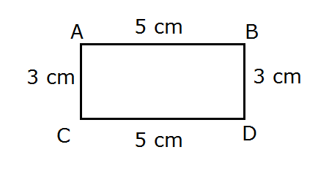=16cm

Use today to measure the perimeter of objects in your home. Compare the perimeters of the objects. Can you find an object with a smaller or larger perimeter? How about one with the same perimeter?

Got a ruler or tape measure? Great use these to help you.

Haven’t got these? There are other options! Measure app on the ipad will help you to find measurements or you can even measure in hands, fingers or feet!

Challenges

* Convert what you have measured to metres or mm
* Find the area of the objects you have measured

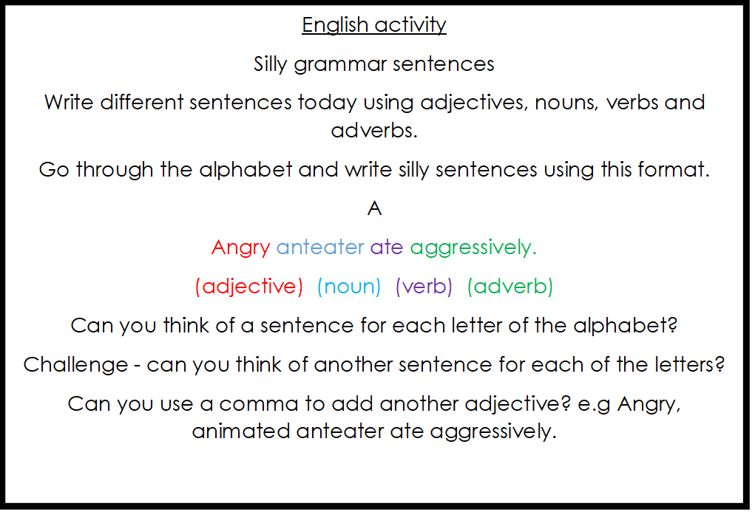

Maths activity

Think about what food would be needed to feed your family for a week. How much do you think a weekly shop would cost?

Write a list of what you would need.

Remember to think about breakfast, lunch, dinner and toiletries that your family might need to last one week.

When you have completed your list, use an online supermarket to check the prices of the goods you have recorded.

When you have found all of you items, add up your prices to find a total cost for the week.

Was it different to your prediction?

Challenge

Is there any way of making your weekly shop cheaper? How?

English activity

Select a book or film that your have recently seen or read.

Write a detailed review of your chosen book/film.

You should try to include the following things:

* Name of book/film and author/director
* A summary of the plot
* Main character name and description
* Genre/type
* Favourite character/moment
* Rating and why
* What could be improved?
* Who would you recommend this to?

PSHE

Think about what makes you special and unique.

Create a picture/poster which celebrates how special you are and recognises how you are different from others.

Include your appearance, your interests and your personality!

Your image may look like this:

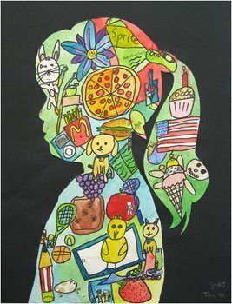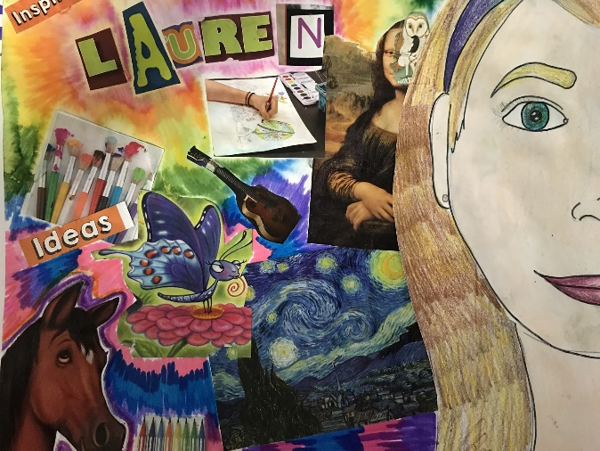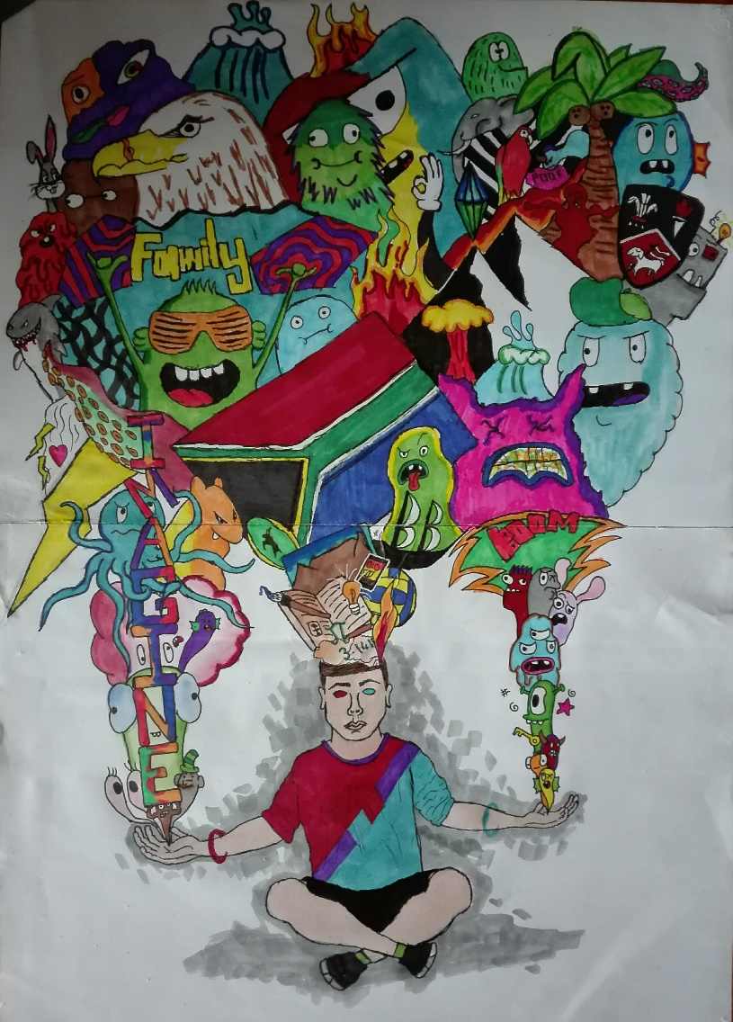

Maths activity

Weight predictions

Select 10 different objects which you can find around your house. Hold each object and try to predict which is the heaviest and lightest.

Put all of the items in order from lightest to heaviest.

* How many of the lightest item do you think would make the weight of the heaviest?
* How much more do you think the heaviest item will weigh than the lightest?

Challenge: If you had to estimate their weight in grams or kilograms, what would you guess?

If you have scales then you should use these to check your prediction. Did you get them all correct? If you estimated, how far off were you?

Don’t have scales?

You may wish to try to make your own. This video might help: <https://www.youtube.com/watch?v=12760IJwMuU>