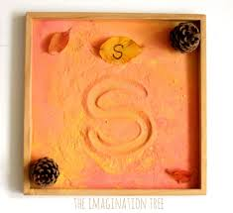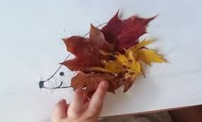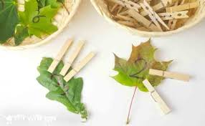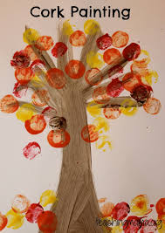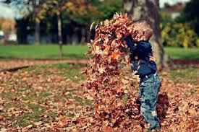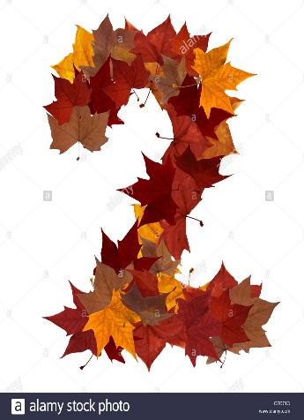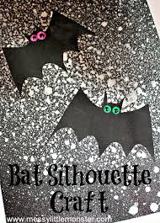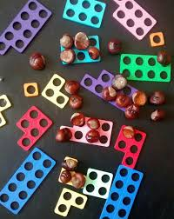

**BLENDED LEARNING- Autumn Overview**

**Health and Well Being**

<https://www.twinkl.co.uk/resource/t-l-54239-little-acorns-cutting-skills-activity-sheet>

Play parachutes games outside, fill the parachute with leaves and then all grab an edge flick them into the air and try to catch them as they fall.

Rake a maze into fallen leaves for the children to follow.

Make dens in the woods for the animals to hibernate in.

Handwashing activities

Discuss the change in seasons and how each season makes us feel.

Talk about how we can help the animals now the weather is getting colder e.g. we could make bird feeders.

<https://www.bbc.co.uk/cbeebies/makes/bird-feeder>

**Humanities**

Take the children on a walk in the locality (woods) and see how many items you can find on your Autumn Hunt Checklist.

<https://www.twinkl.co.uk/resource/t-t-22426-autumn-hunt-checklist>

Rolling conkers

Exploring animals (patterns, What they eat, nocturnal)

Laminating leaves

**Language, Literacy and Communication**

Listen and join in with rhymes related to Autumn/winter

Listen to stories based on our autumn theme, are the children able to retell the stories. They may do this in a variety of ways, answering questions about the story, retell the story by acting it out or sequence picture cards from the story.

Mark making:- Practise forming patterns in the sand, in the foam, using chalk or paint, jewels etc.

Recognising themselves- using photos

Name cards daily – Recognise your name card, over writing (join the dots), initial sounds and over writing.

Developing fine motor skills using pegs and tweezers (adding pegs to a hedgehog to make prickles)

Speech and Language programmes

Tap Tap Box

Bucket Time

**Science and Technology**

Read books about the season Autumn and winter

Watch Educational Autumn video on You tube.

CBeebies – Autumn animals Autumn watch

Go on an Autumn walk with the children ask the children what they notice, the weather is getting colder, the leaves are changing colour and it’s getting darker. Collect leaves and conkers for future activities.

Talk about and list the animals that hibernate.

<https://www.twinkl.co.uk/resource/t-l-54302-dont-hog-the-hedge-hibernating-animals-differentiated-fact-file>

Leaf rubbings.

Gather a basket of clothes for all seasons and get the children to think what items they would need now the weather is getting cooler.

**Expressive Arts**

Make a leaf crown.

Conker rolling. Dip the conker in some paint (Autumn colours) and roll it along the paper, choose another conker and colour and repeat building up layers using different colours. Reinforce the names of the colours in English and Welsh

Hedgehog craft (see pic above).

Bat craft – Place a bat template over a piece of black paper. Place white paint in a spray bottle and decorate the sky.

Experiment with colour mixing – create autumn colours different shades of brown, red, orange and yellow.

Making leaf hedgehogs

**Maths and Numeracy**

**Sorting** Collect a broad selection of leaves for sorting. Discuss different ways we can sort them e.g. shape, size and colour. Sort them into large hoops, once you have done this count together how many in each hoop.

**Patterns** Create a pattern using natural objects in the environment e.g. twig, berry, leaf and so on.

**Counting** Give the children 60 seconds to collect as many leaves as possible. Once the time is up, gather back in a circle, get each child to count how many leaves they have (support them if needed) and see who collected the most.

**Counting and Numicon** Pull a Numicon shape out of the bag and match it to the correct amount of conkers.

**Number flashcards** 1-3, 1-5, 1-10 depending on child’s ability.

**Number recognition** Adult draw a number on a leaf, can the children identify the number and place that amount of pegs on the leaf (see picture above).

**Number formation** sing formation rhymes daily. Practise forming numbers in the mud using sticks. Form the numbers using natural objects and leaves.

**Suggested Books**

Owl Babies by Martin Waddell

Famer Duck by Martin Waddell

The Gruffalo by Julia Donaldson

Tree: Seasons by Patrica Hegarty

Room on the Broom by Julia Donaldson

Percy The Park Keeper by Nick Butterworth.