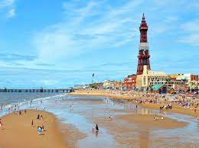 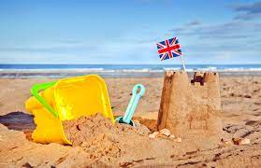 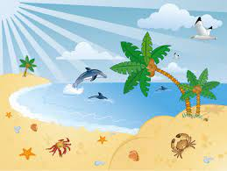 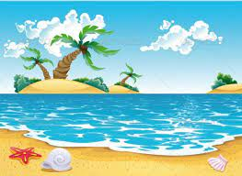 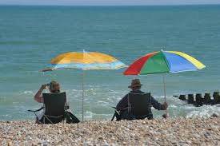

**Expressive Arts**

Make a sand castle.

Make ice cream cones

Use different sensory products to explore the seaside (jelly, ice, sand)

Reinforce the names of the colours in English and Welsh

Experiment with colour mixing – create summer colours different shades of blue, red, orange and yellow.

Use shaving foam and blue powder paint to make water art

Use a range of musical instruments and listen to waves and other sea sounds

Cutting skill practice

Paint feet with white paint and dip ionto sand to make ‘sandy toes’

**Maths and Numeracy**

**Sorting** Collect a broad selection of leaves for sorting. Discuss different ways we can sort them e.g. shape, size and colour. Sort them into large hoops, once you have done this count together how many in each hoop.

**Patterns** Create a pattern using natural objects in the environment e.g. twig, berry, leaf and so on. Decorate sandcastles with shells

**Counting** Give the children 60 seconds to collect as many leaves/flowers as possible. Once the time is up, gather back in a circle, get each child to count how many leaves they have (support them if needed) and see who collected the most.

**Counting and Numicon** Pull a Numicon shape out of the bag and match it to the correct amount of flowers, sea shells. Adding cereal hoops to starfish and octopus legs

**Number flashcards** 1-3, 1-5, 1-10 depending on child’s ability.

**Number recognition** counting, sorting, addition and subtraction. Using numicons to add one more/one less. Seaside matching games

**Number formation** sing formation rhymes daily. Practise forming numbers in the mud using sticks. Form the numbers using natural seaside objects such as shells.

Water play, measuring activities

Colour sorting/matching activities

**Health and Well Being**

Play parachutes games outside, fill the parachute with leaves and then all grab an edge flick them into the air and try to catch them as they fall.

Handwashing activities

Discuss the change in seasons and how each season makes us feel.

Talk about how we can help the animals now the weather is getting warmer e.g. we could make bird feeders.

Use mirrors to help recognise self

Talk about emotions using symbols/emojis

Tasting ice cream

**Summer Overview- Sandy Toes**

**Science and Technology**

Read books about the season summer

Watch Educational videos about the seaside, waves crashing, wet and dry sand, what happens at the pier on holidays

Explore a range of different textures such as wet and dry sand, jelly, warm water, ice cubes

Go on a summer walk with the children ask the children what they notice, the weather is getting warmer, the leaves are changing colour Talk about and list the animals that hibernate.

Planting sunflower seeds

Leaf rubbings.

Gather a basket of clothes for all seasons and get the children to think what items they would need now the weather is getting warmer.

**Language, Literacy and Communication**

Listen and join in with rhymes related to summer

Listen to stories based on our summer theme, are the children able to retell the stories. They may do this in a variety of ways, answering questions about the story, retell the story by acting it out or sequence picture cards from the story.

Mark making: - Practise forming patterns in the sand, in the foam, using chalk or paint, jewels etc.

Activities linked to ‘Sharing a shell’- sequencing the story, talking about characters

Recognising themselves- using photos

Using symbols to ask for things (i.e.- ice cream flavours)

Name cards daily – Recognise your name card, over writing (join the dots), initial sounds and over writing.

Developing fine motor skills using pegs and tweezers (adding pegs to a octopus legs to make prickles)

Speech and Language programmes

Tap Tap Box

Bucket Time

**Humanities**

Take the children on a walk in the locality (woods) and see how many items you can find on your summer Hunt Checklist.

Making sandcastles using dry and wet sand

Decorating sandcastles with shells

Exploring ice cubes and temperature

Looking at pictures 0of beaches, sea and land- talking about different vehicles that may use the different areas

Exploring our local area- classroom and outdoor provision